**😊 Amazon QuickSight**

Amazon QuickSight is a cloud-based business intelligence (BI) service offered by Amazon Web Services (AWS). It is designed to help organizations analyze their data and create interactive visualizations and dashboards. Here are the main components and features:

**Key Features**

1. **Data Sources**:
   * QuickSight can connect to a variety of data sources, including:
     + AWS services (Amazon S3, Redshift, RDS, Athena)
     + On-premises databases (via AWS Direct Connect)
     + Third-party data sources (such as Salesforce, MySQL, and more)
2. **Data Visualization**:
   * Users can create a wide range of visualizations, including line charts, bar graphs, pie charts, heat maps, and geospatial maps, to represent data insights effectively.
3. **SPICE Engine**:
   * SPICE (Super-fast, Parallel, In-memory Calculation Engine) enables fast querying and processing of large datasets, allowing for quick response times even with complex calculations.
4. **Interactive Dashboards**:
   * Dashboards can be customized and published for users to interact with, including filtering and drilling down into data for deeper insights.
5. **Machine Learning Insights**:
   * QuickSight provides built-in machine learning capabilities, enabling users to uncover trends, forecast data, and identify anomalies without requiring data science expertise.
6. **Collaboration and Sharing**:
   * Dashboards can be easily shared with other users or teams, allowing for collaborative decision-making. QuickSight also supports embedding dashboards in applications or websites.
7. **Security and Compliance**:
   * QuickSight integrates with AWS Identity and Access Management (IAM) for user authentication and access control, ensuring that data is secure and compliant with regulations.
8. **Scalability**:
   * As a cloud-native service, QuickSight can scale automatically to accommodate varying workloads and data sizes.

**Use Cases**

* **Business Analytics**: QuickSight is often used for performance tracking, sales analysis, and operational reporting.
* **Financial Reporting**: It enables finance teams to visualize revenue, expenses, and profitability metrics.
* **Customer Insights**: Marketing teams can analyze customer behavior and campaign performance.

**Pricing**

QuickSight uses a pay-per-session pricing model, which can be cost-effective for organizations with varying usage patterns. Pricing typically includes charges based on the number of users and the amount of data processed.

**Conclusion**

Amazon QuickSight provides a powerful and user-friendly platform for data analysis and visualization, making it suitable for businesses looking to leverage their data for informed decision-making without the need for extensive IT resources.

**😄 To begin with the Lab:**

1. Log in to your AWS Console and search for QuickSight. Then you will on this screen shown below. You need to click on Sign up for QuickSight.

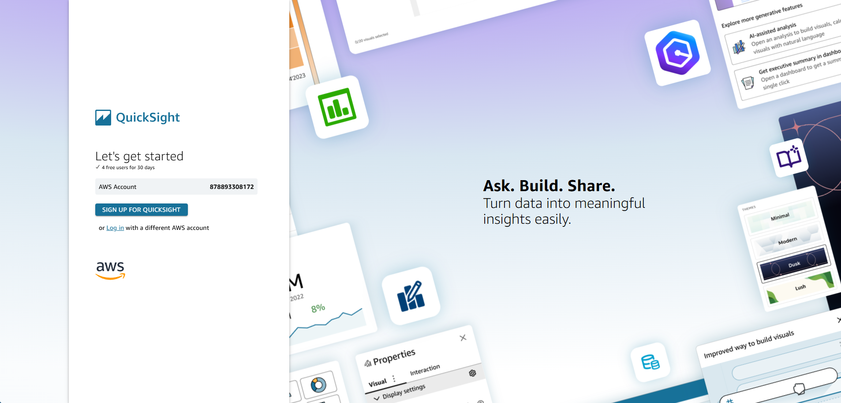

1. Then for sign-up details you can provide your Email Address and the account name. Choose a region of your choice.

1. After that keep everything to default and cancel the add-on optional feature. Click on finish.

1. Below you can see that our QuickSight account has been created.

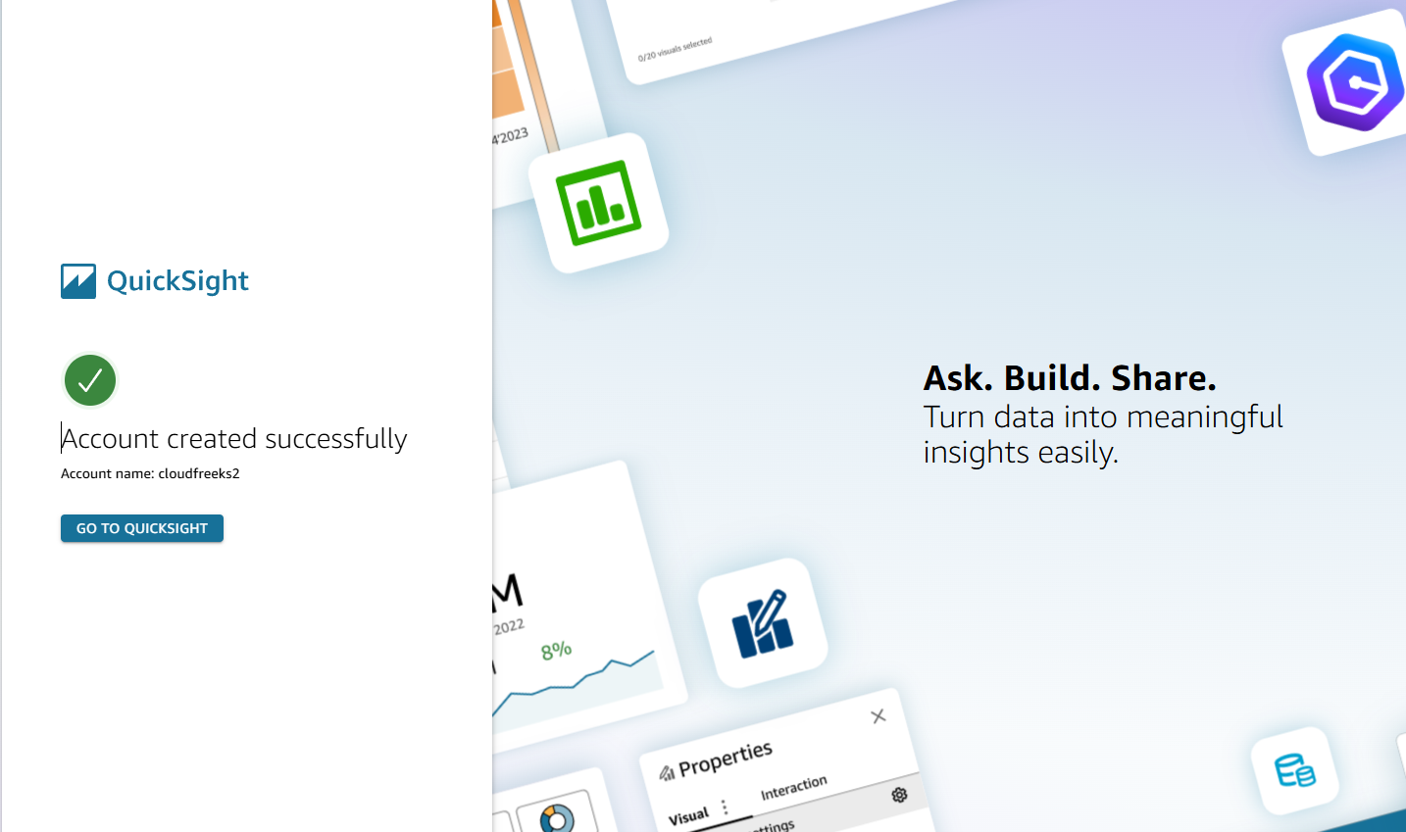

1. Below you can see the dashboard of QuickSight. Click on New Analysis.

1. Click on New dataset. Then choose Upload a file, after that you need to choose the with name web-and-social-analytics and upload it.

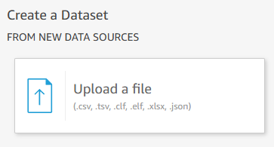

1. Then it will ask you for the confirmation, click on next.

1. In the end just click on visualize.

1. After that choose the interactive sheet and click on create.

1. Below you can see that you have multiple options available.

1. To visualize our data we chose Data and Mail list adds and you can see the visualization.

1. Below you can see that on the X-axis I have changed the date to Months and you have the data in more interactive manner.

1. In summary, Amazon QuickSight is a cost-effective, fast, and interactive business intelligence tool designed for enterprises. It can handle multiple large data sources and enables smart visualizations, enhancing data analysis. QuickSight also boosts productivity with features like an interactive graphical user interface and the ability to share visualizations easily.